
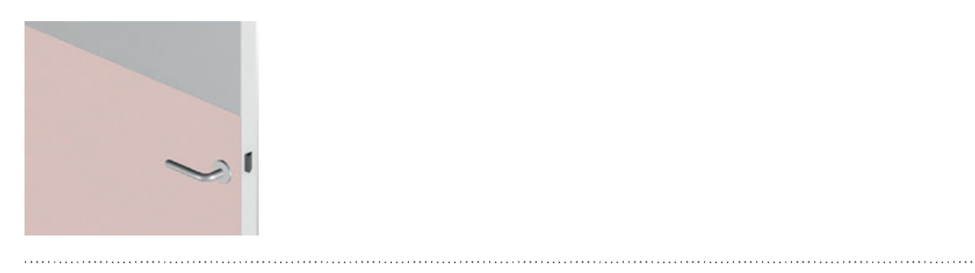

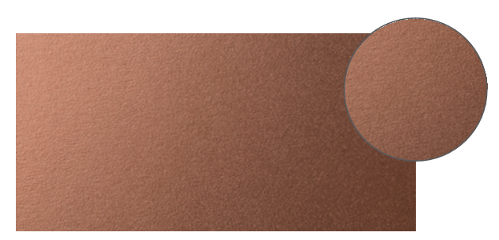

SPECIFICATION

HALF-HEIGHT DOOR
DECOCHOC / DECOSMIC
PROTECTION AND COVERING PANELS – STRAIGHT CUT

- Description: 2 mm thick protection and covering panel (Decochoc or Decosmic as manufactured by SPM) from rigid and antibacterial PVC achieving Bs2d0 fire rating with solid colour and slightly textured surface.
- Environment: no heavy metals and no substance potentially subjected to any REACH restriction are used in its manufacture, nor PBT/BPA. The calcium-zinc thermal stabilization process is used. The emission level of volatile substance in inside air has been tested according to ISO 16000-6 and is very low (A+) according to the French regulation (23 March 2011 nr 2011-321 Decree and 19 April 2011 Order). 100% of the product are recyclable.
- Colour: selected by architects from manufacturer’s standard range.
- Installation method: glue as per manufacturer’s instructions.
